1. Write a SQL query to count the number of characters except the spaces for each actor. Return first 10 actors name length along with their name.

Ans-- select concat(first_name,' ',last_name) as fullName,char_length(trim(concat(first_name,last_name)))

from actor;

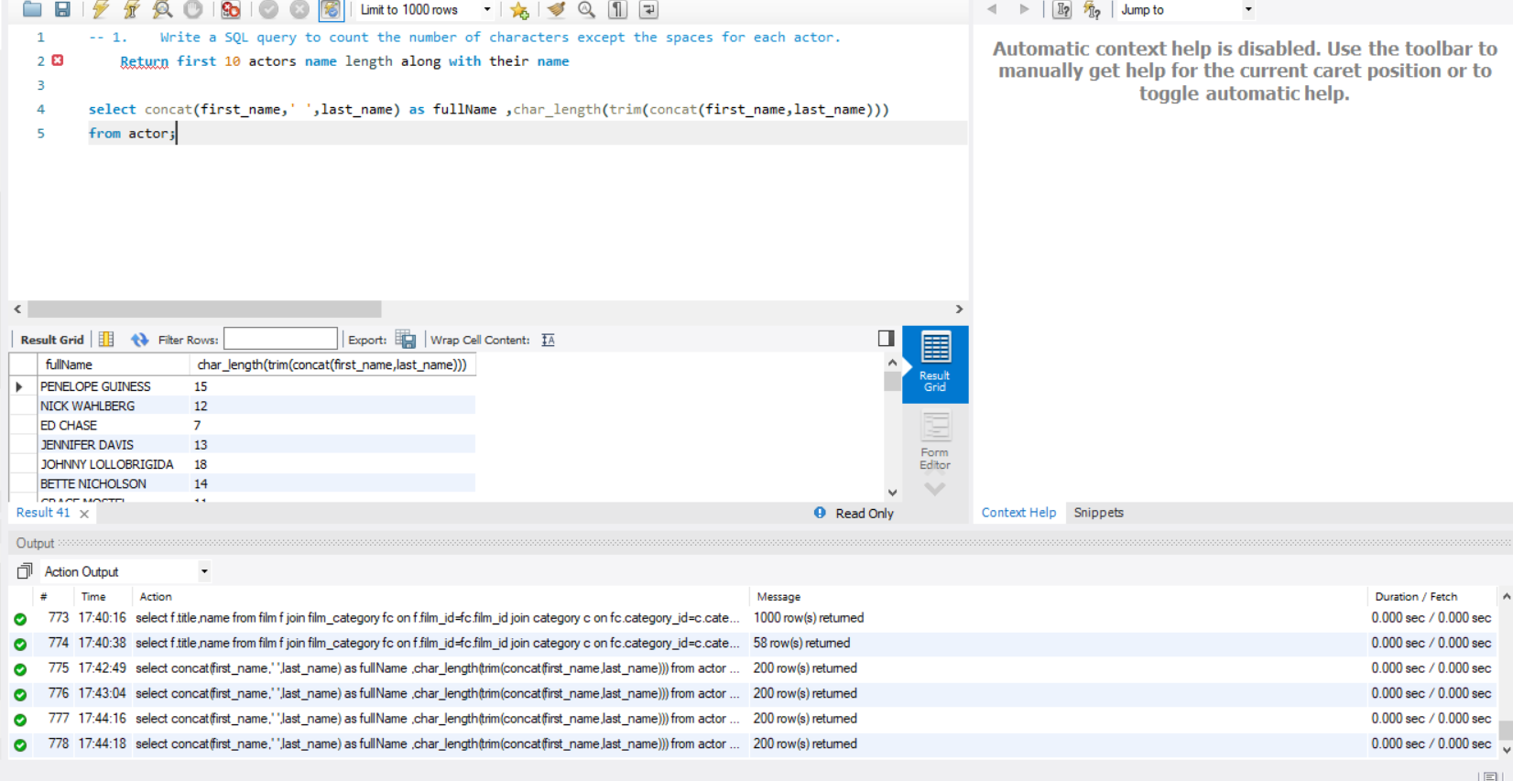

2- List all Oscar awardees(Actors who received Oscar award) with their full names and length of their names.

Ans-- select char_length(concat(first_name,last_name)) as len_names ,

concat_ws(' ',first_name,last_name) as full_name,awards

from actor_award where awards in ('oscar') ;

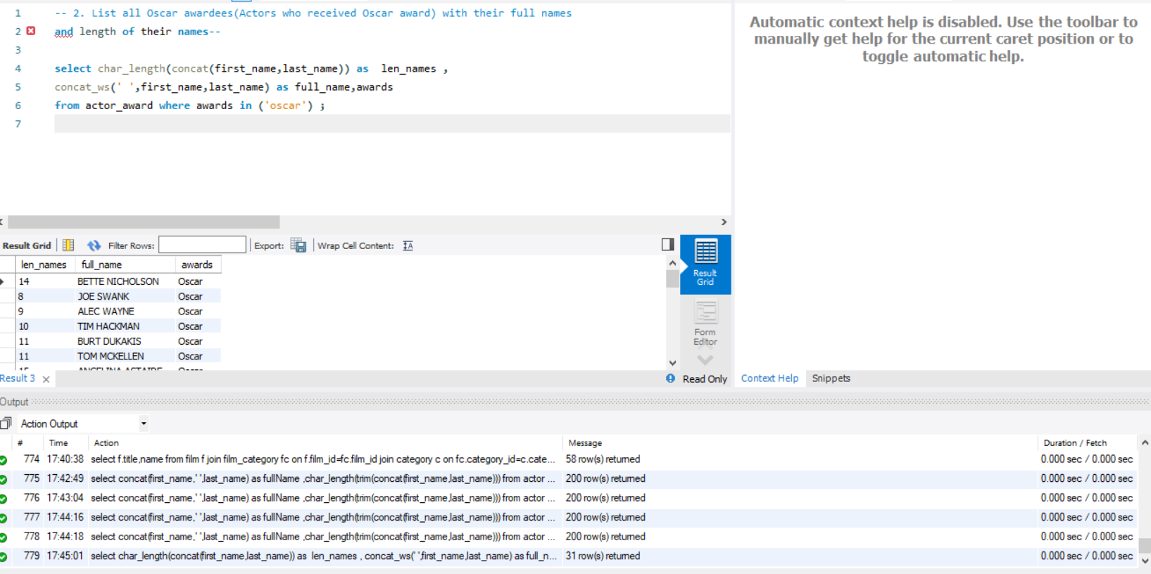

3-- Find the actors who have acted in the film ‘Frost Head’.

Ans-- select concat_ws(' ',first_name,last_name) actorName

from actor a join film_actor fa on a.actor_id=fa.actor_id

join film f on fa.film_id=f.film_id

and f.title='frost head';

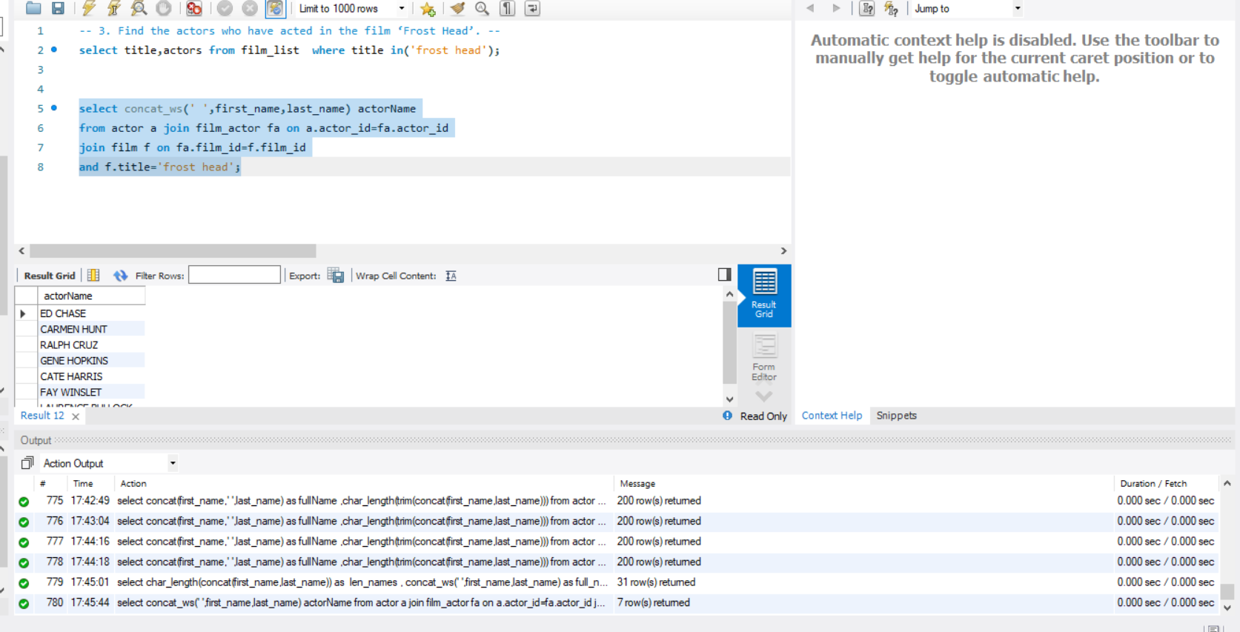

4- Pull all the films acted by the actor ‘Will Wilson’.

Ans- select f.title as film from film as f

join film_actor as fa on f.film_id=fa.film_id

join actor as a on fa.actor_id=a.actor_id

and first_name ='will' and last_name='wilson';

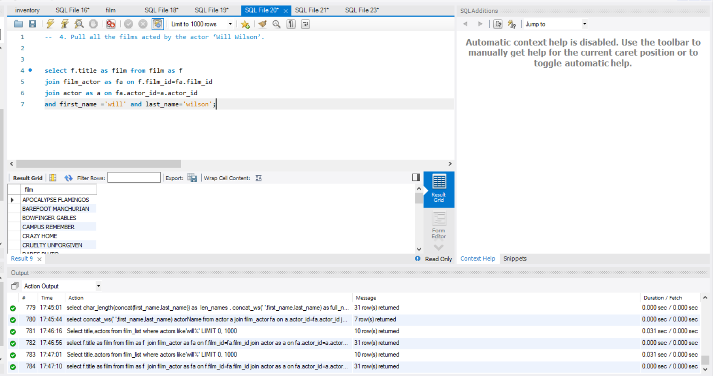

1. Pull all the films which were rented and return in the month of May.

Ans-- select f.title,r.rental_date,r.return_date,monthname(rental_date),monthname(return_date) from film f

join inventory i on f.film_id=i.film_id

join rental r on i.inventory_id=r.inventory_id

where month(rental_date)=5 and month(return_date)=5;

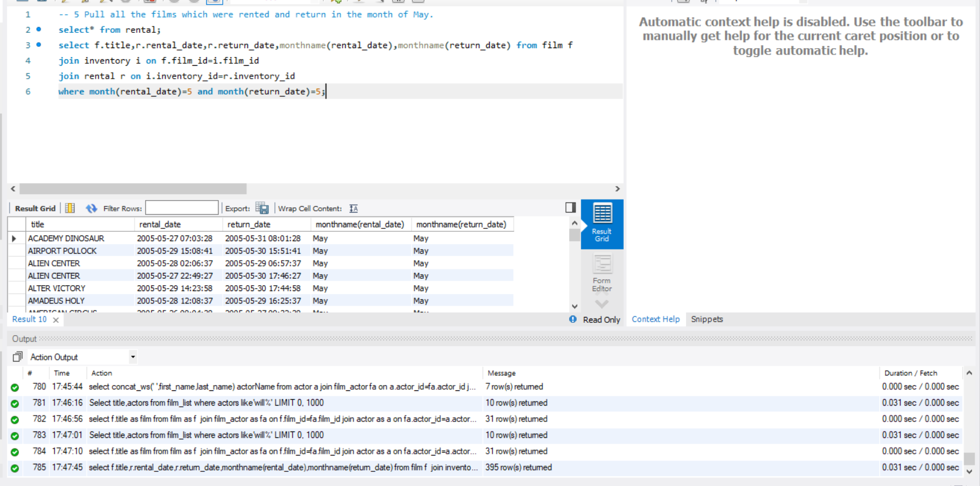

6-- Pull all the films with ‘Comedy’ category.

Ans- select f.title,name from film f

join film_category fc on f.film_id=fc.film_id

join category c on fc.category_id=c.category_id

where name='comedy';

